#Problem 2

b)

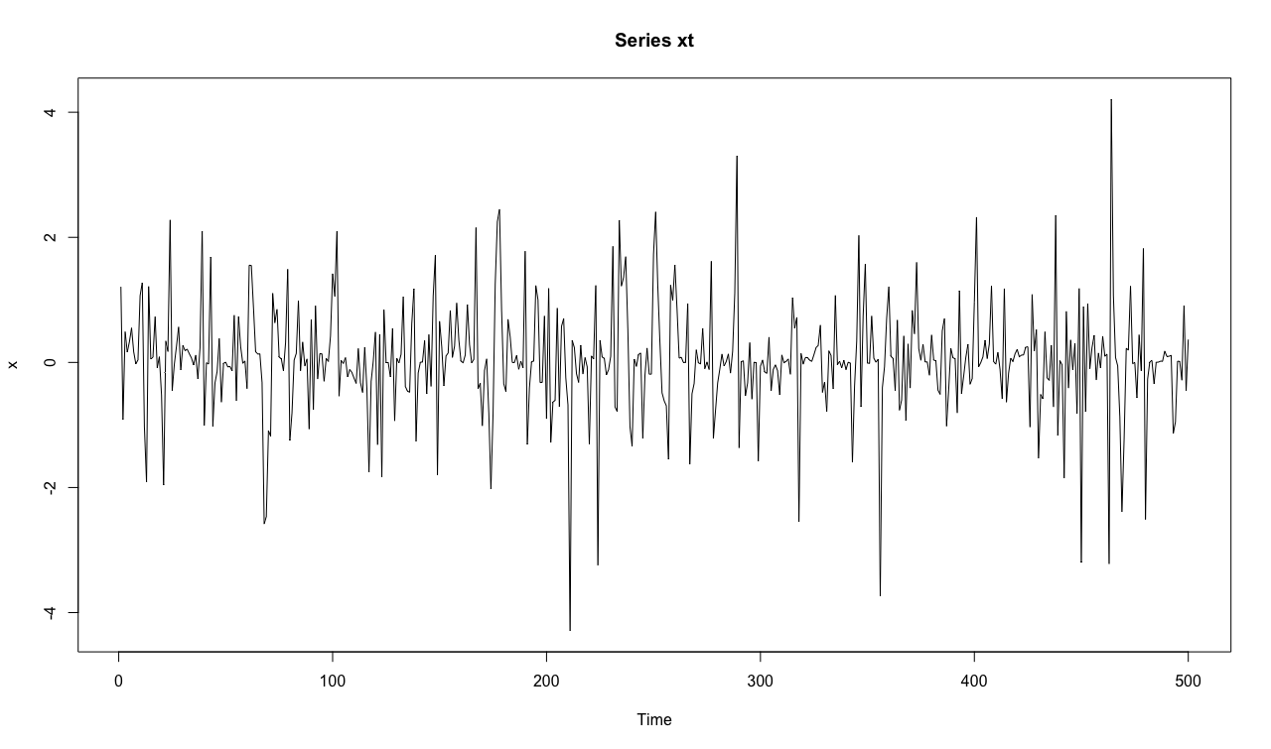

If we look at the times series, it seems to seasonal variation in number per time unit, there are peaks from time to showing this.

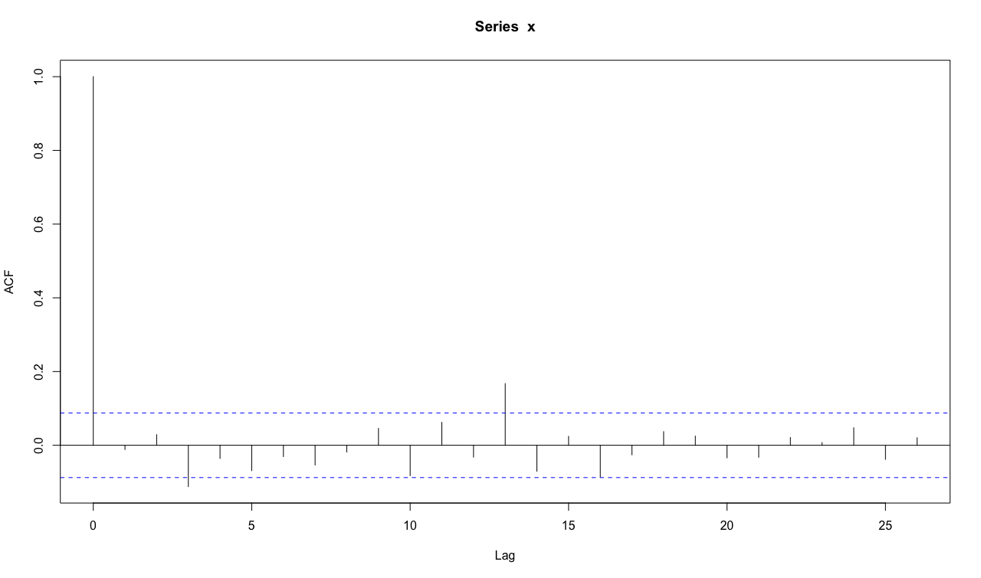

From the ACF test, we can see that the autocorrelation at lag 1 is just touching the significance bounds.

c)

Box.test(x,lag=1,type='Ljung')

m=1

data: x

X-squared = 0.067359, df = 1, p-value = 0.7952

Box.test(x,lag=2,type='Ljung')

m=2

data: x

X-squared = 0.48274, df = 2, p-value = 0.7856

Box.test(x,lag=3,type='Ljung')

m=3

data: x

X-squared = 6.8458, df = 3, p-value = 0.07698

Box.test(x,lag=4,type='Ljung')

m=4

data: x

X-squared = 7.4957, df = 4, p-value = 0.1119

Box.test(x,lag=5,type='Ljung')

m= 5

data: x

X-squared = 9.8958, df = 5, p-value = 0.07824

Box.test(x,lag=6,type='Ljung')

m=6

data: x

X-squared = 10.373, df = 6, p-value = 0.1098

Problem 3

a)

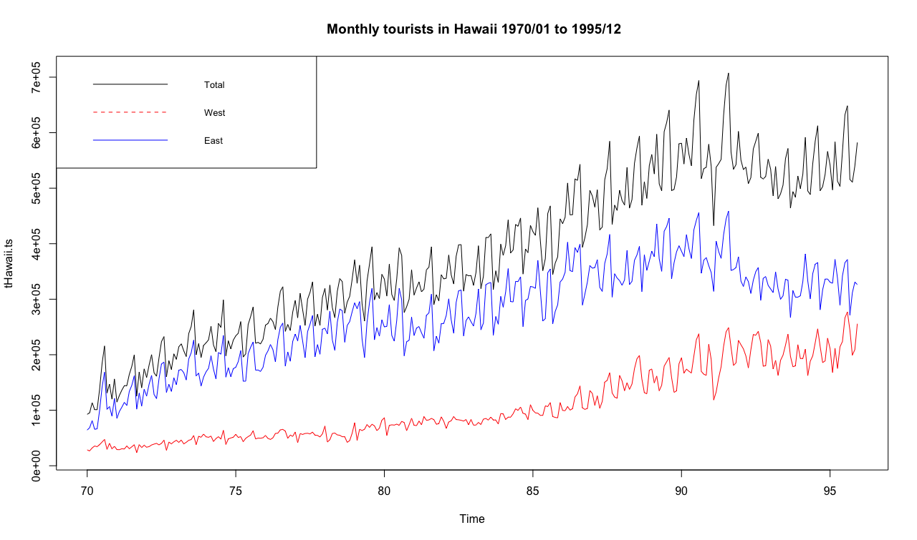

The Total and East the plots seems to follow an upward linear trend until the year 92 aproximately, where a shift down happens, a more a drastical one for the East plot. Then the Total returns to the upward trend,but the East remains in a horizontal trend. In the West plot, we can see that it keeps an upward trend the whole time, what seems to be a quadratic trend.

Also the three present a seasonal pattern, higher on the summer months and lower on the winter ones.

As supposed, the total plot is higher than both West and East, but as times goes, especially since year 88 aproximately, the West plot begins to grow more while the East begans to go down.

b)

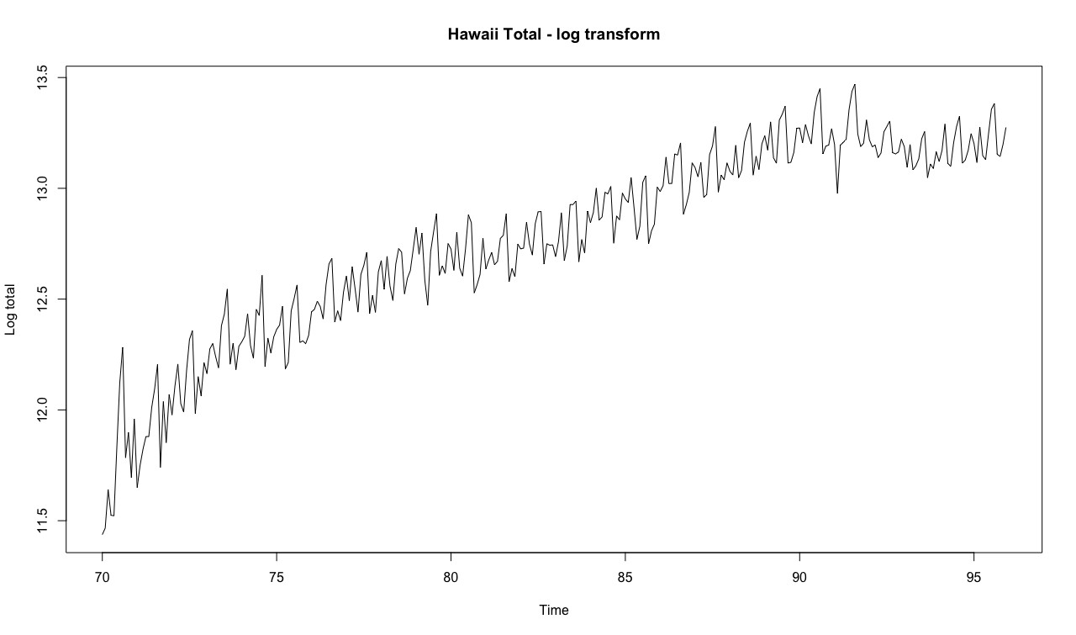

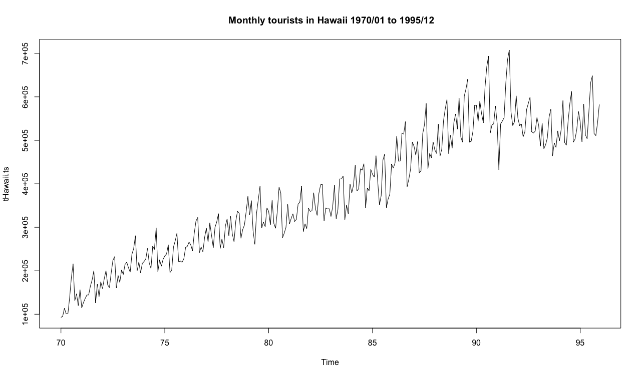

As we can see when comparing both graphs, the trend from the log transformation is practically the same as the original time series, so nothing really changes when performing the log transformation.

Problem 4

b)

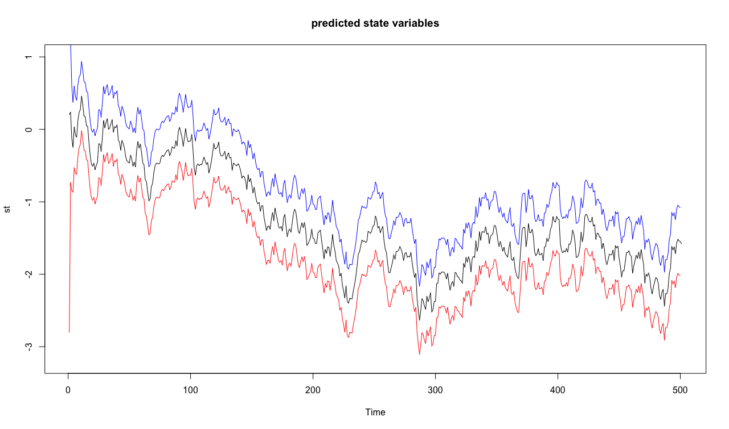

c) 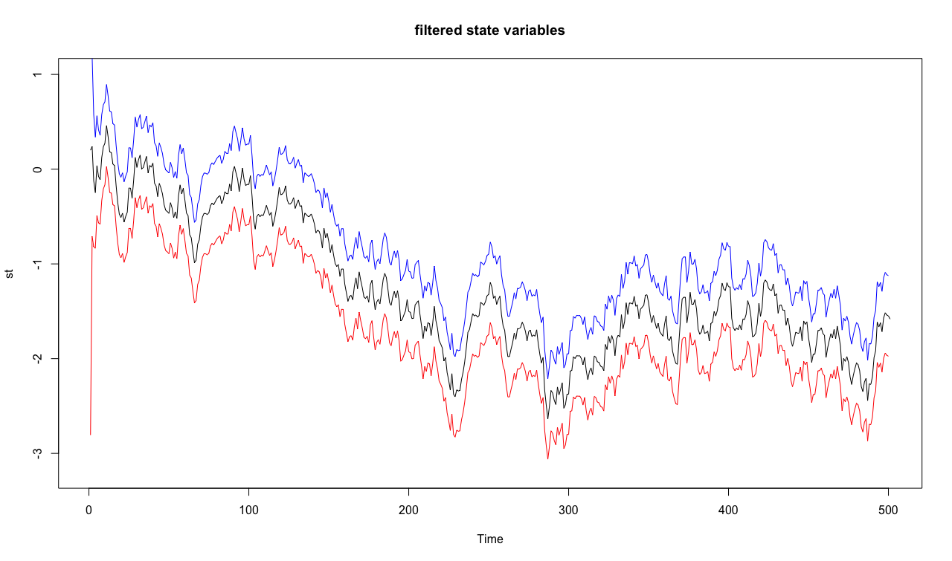

d) 